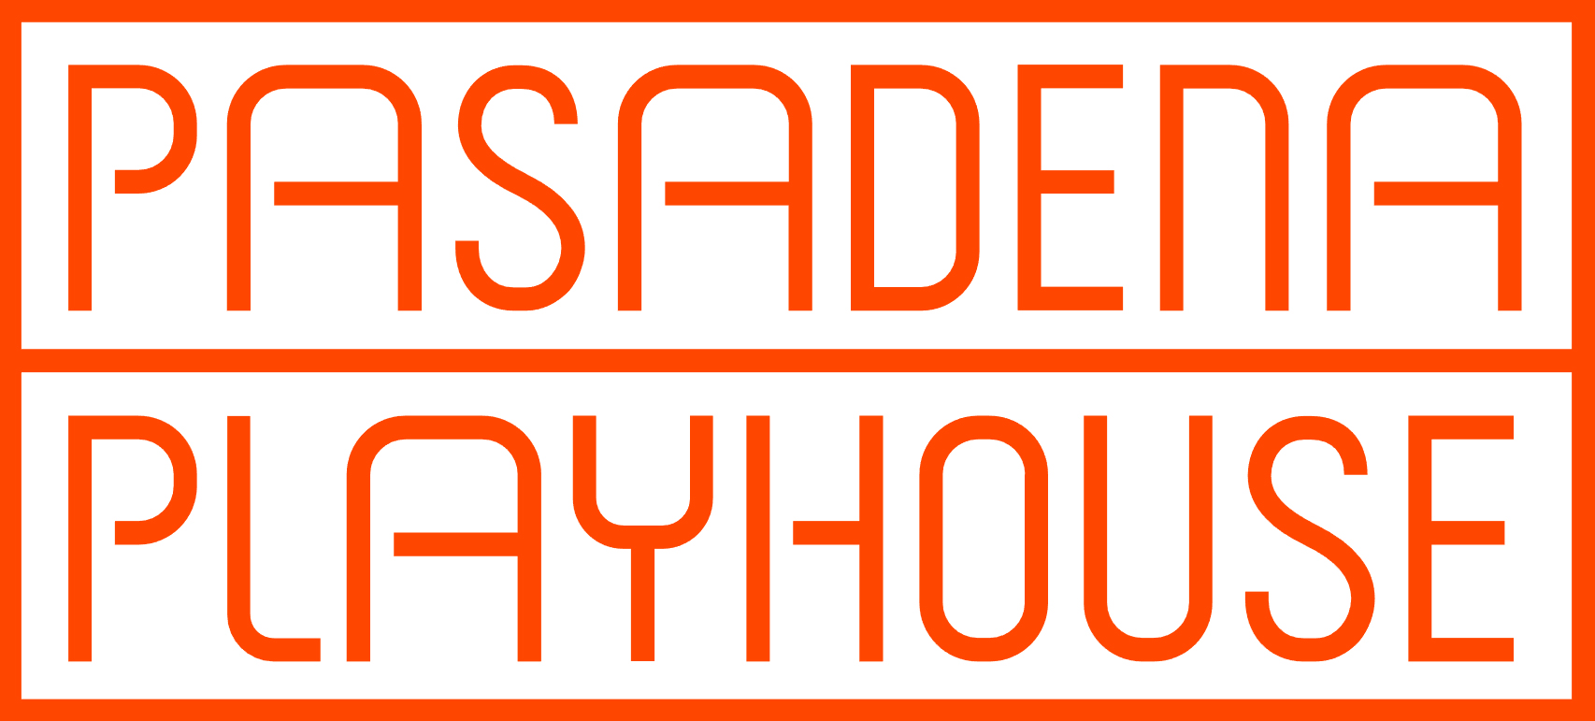
Contact: Davidson & Choy Publicity | Tim Choy t.choy@dcpupblicity.com
Peter Goldman p.goldman@dcpublcity.com | 323 954 7510

Kory Kelly – Director of Marketing at Pasadena Playhouse: kkelly@pasadenaplayhouse.org / 626 243 7009

“Just as you were thinking that life has no rhyme nor reason, along comes freestyle love supreme to pump you full of hope.” – The New York Times

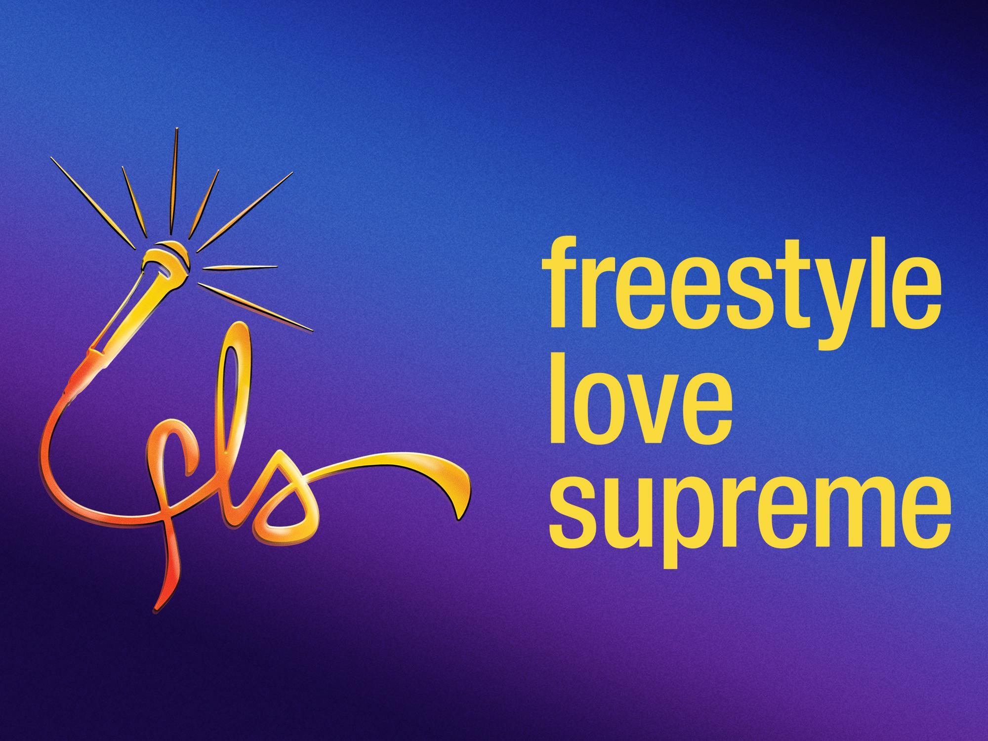

Conceived by Anthony Veneziale and created by
Thomas Kail, Lin-Manuel Miranda and Anthony Veneziale

Recipient of a 2020 Special Tony Award®,
The critically acclaimed Hip-Hop sensation
arrives at Pasadena Playhouse
July 12 – August 7, 2022

Tickets at www.pasadenaplayhouse.org or by calling 626-356-7529

June 15, 2022, Pasadena, CA | Producers Thomas Kail, Lin-Manuel Miranda, Jenny and Jon Steingart, Jill Furman and Pasadena Playhouse Producing Artistic Director Danny Feldman announce that the national tour of FREESTYLE LOVE SUPREME will play Pasadena Playhouse July 12-August 7, 2022.

The critically acclaimed hip-hop sensation and recipient of a 2020 Special Tony Award was conceived by Anthony Veneziale and created by Thomas Kail, Lin-Manuel Miranda and Anthony Veneziale in 2004 before In The Heights and Hamilton. Following a highly anticipated Broadway return and the release of the Grammy nominated Hulu documentary We Are Freestyle Love Supreme, this “hugely entertaining dream of a show and a phenomenon” (Time Out New York) is a non-stop blend of hip-hop, improvisational theater, music, and vocal stylings. The 90-minute show, called “completely genius” by Politico, is created nightly with the audience and no two shows are ever the same.

“We’ve had many of our happiest and most fulfilling creative moments working on freestyle love supreme and are excited to see its next chapter unfold on this national tour,” said Thomas Kail and Lin-Manuel Miranda. “It is a show that consistently surprises us: we have no idea what to expect any time we do it - and isn’t that the true beauty of live theater? freestyle love supreme wouldn’t want or have it any other way!”

Directed by Kail, FREESTYLE LOVE SUPREME is a blend of hip-hop, improvisational theater, music and vocal styling with special surprise guests at select performances. The show that Entertainment Weekly calls “lightning in a bottle” and Rolling Stone describes as “pure joy” features talented performers providing non-stop action throughout this fast-paced evening, spinning suggestions from the audience into humorous bits, instantaneous songs and riffs, and fully realized musical numbers. The electrifying vocals of the performers – from singing to rapping to beat-boxing with harmonies and freestyle flow – are backed by tight tunes from keyboards and human percussion.

FREESTYLE LOVE SUPREME’s company on tour includes Andrew Bancroft AKA “Jelly Donut,“
Richard Baskin, Jr. AKA “Rich Midway;” Jay C. Ellis AKA “Jellis J;” Aneesa Folds AKA “Young Nees;”
Mark Martin AKA “Mandible,” Kaila Mullady AKA "Kaiser Rözé; Morgan Reilly AKA “Hummingbird;” James Rushin AKA “Shifty Hills;” Victoria Theodore AKA “Gigawatts;” and Anthony Veneziale
AKA “Two Touch.”

Special spontaneous and unannounced guests are planned for select performances during the tour.

In name and beyond, FREESTYLE LOVE SUPREME pays homage to John Coltrane's "A Love Supreme", with a nod to musical roots in jazz, soul, blues and hip-hop. FREESTYLE LOVE SUPREME was originally developed and produced in 2004 by Ars Nova, in association with Jill Furman and Back House Productions. The show has played in all five boroughs of New York and many states, as well as on Broadway, at the U.S. Comedy Festival, Edinburgh Fringe Festival, Melbourne Comedy Festival, and the Montreal Just for Laughs Festival.

FREESTYLE LOVE SUPREME is produced by Thomas Kail, Lin-Manuel Miranda, Jenny and Jon Steingart, and Jill Furman. It features set design by Beowulf Boritt; costume design by Lisa Zinni; lighting design by Jeff Croiter; and sound design by Nevin Steinberg.

Tickets are on sale now, starting at $30 and are available at pasadenaplayhouse.org by phone at 626-356-7529, and at the box office at 39 South El Molino Avenue, Pasadena, CA 91101.

Connect with FREESTYLE LOVE SUPREME online:
www.freestylelovesupreme.com.
Twitter: @FreestyleLove
Facebook: @FreestyleLoveSupreme
Instagram: @FreestyleLoveSupreme

# # #
.
ABOUT THE PASADENA PLAYHOUSE
Pasadena Playhouse is a place where people have gathered for 100 years to experience bold and important theater. It is one of the most prolific theaters in American history with a legacy of profound theatrical impact and courageous new work. In 1937, the Playhouse was officially recognized as the State Theater of California for its contribution and commitment to the dramatic arts. Today it continues that tradition of excellence under the helm of producing artistic director Danny Feldman. Dedicated to enriching lives through theater, community programs and learning initiatives, Pasadena Playhouse is a living force in the community.

Calendar Listing for FREESTYLE LOVE SUPREME

Venue: Pasadena Playhouse, 39 South El Molino Avenue, Pasadena, CA 91101

Dates: Tuesday, July 12 to Sunday, August 7
Press opening Thursday, July 14 at 8:00 p.m.

Tickets: Prices start at $30
Online -- PasadenaPlayhouse.org
By phone at 626-356-7529
In person -- Pasadena Playhouse Box Office, located at 39 South El Molino Avenue, Pasadena, CA 91101

Performance Schedule: Wednesday-Friday evenings at 8:00 p.m.
Saturday at 2:00 p.m. and 8:00 p.m; Sunday at 2:00 p.m.
Additional performance on Tuesday, July 19 at 8:00 p.m.
Additional Sunday, August 7 closing night performance at 7:00 p.m.

