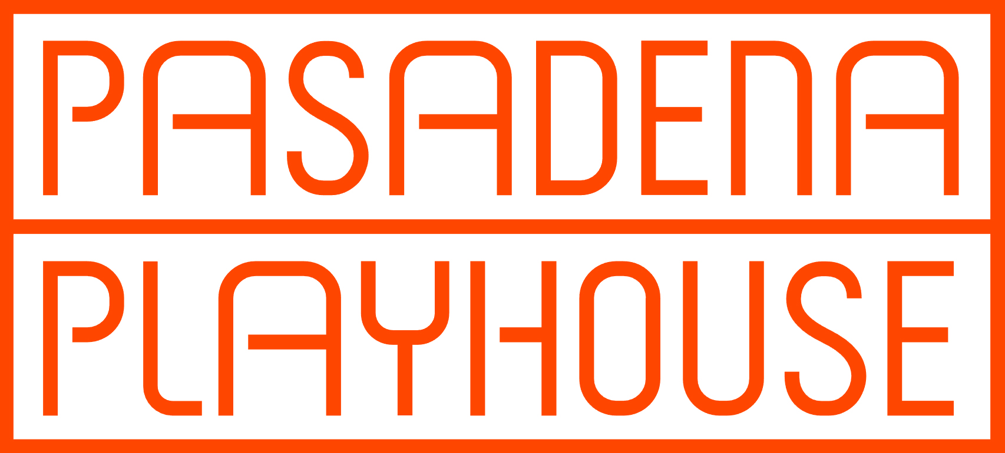
Contact: Davidson & Choy Publicity | Tim Choy t.choy@dcpupblicity.com
Peter Goldman p.goldman@dcpublcity.com | 323 954 7510

Kory Kelly – Director of Marketing at Pasadena Playhouse: kkelly@pasadenaplayhouse.org / 626 243 7009

“Majok has given us something that transcends politics as only the best and most humane art can.” – New York Stage Review
The Los Angeles Premiere of
SANCTUARY CITY
by Martyna Majok
Directed by Zi Alikhan

Now through October 9, 2022

Tickets at www.pasadenaplayhouse.org or by calling 626-356-7529

September 18, 2022, Pasadena, CA | Pasadena Playhouse presents the Los Angeles premiere of Sanctuary City by Pulitzer Prize-winner Martyna Majok (Cost of Living) now through October 9, 2022.

The production stars Ana Nicolle Chavez (Apple TV +’s Truth Be Told) as “G,” Miles Fowler (HBO’s Winning Time) as “B” and Kanoa Goo (ABC’s The Rookie) as “Henry.”

The creative team features direction by Zi Alikhan; scenic design by Chika Shimizu; costume design by Jojo Siu; lighting design by Solomon Weisbard; sound design by John Nobori; intimacy choreography by Amanda Rose Villarreal; and stage management by Brandon Hong Cheng.

In Sanctuary City, two typical American teenagers are just trying to get through high school, navigating the pressures of an unstable home, prom invites and graduation – and the threat of deportation. When she is naturalized, they hatch a plan to help him, but life, time, and distance threaten to push them apart. Can they make their way back to each other, or are the risks too great when they have everything to lose?

Recipient of the Edgerton Foundation New Play Award and Laurents/Hatcher Foundation Theater Development Grant, Sanctuary City “makes for a compelling contemporary drama that has enigmatic characters, rising intensity, vigorous argumentation, timely themes, and an underlying sense of humor and compassion.” (amNY). In addition to the Los Angeles premiere of Sanctuary City, Majok’s Pulitzer Prize-winning Cost of Living opens on Broadway October 3.

Tickets starting at $30 and are available at pasadenaplayhouse.org by phone at 626-356-7529, and at the box office at 39 South El Molino Avenue, Pasadena, CA 91101.

BIOGRAPHIES

Ana Nicolle Chavez, an actress born and raised in Arizona, is a graduate of the State University of New York, Purchase College Acting Conservatory (BFA 2021). Television credits: Season 3 character arc on Truth Be Told on Apple TV+. Film work: Forgotten Lovers.

Miles Fowler can next be seen in MGM's Orion Picture's feature film Bottoms directed by Emma Seligman. His past credits include HBO's Winning Time, Fox's The Resident, and the ABC Limited Series Women of the Movement. Miles studied at USC, where he received a B.A in the Dramatic Arts. Miles Fowler is represented by Authentic Talent and Literary Management.

Kanoa Goo is an actor who recently starred in the film I Was A Simple Man, which premiered in competition at the Sundance Film Festival and is now streaming exclusively on Criterion. He can currently be seen in a major recurring arc as Chris Sanford on ABC’s The Rookie. Other films include Other People opposite Jesse Plemons, Velvet Buzzsaw, Endings, Beginnings, and I Am Michael. Past television includes the NBC pilot Someone Out There, City On A Hill (Showtime), NCIS: Hawai’i (CBS), The Fairly OddParents (Paramount+), Hawai’i Five-0 (CBS), and Dwight In Shining Armor (Paramount Worldwide/BYUtv). Kanoa was born and raised in Honolulu, Hawai’i.

Martyna Majok was born in Bytom, Poland and raised in Jersey and Chicago. She was awarded the 2018 Pulitzer Prize for Drama for her play, Cost of Living. Other plays include Sanctuary City, Queens, and Ironbound, which have been produced across American and international stages. Awards include The Academy of Arts and Letters’ Benjamin Hadley Danks Award for Exceptional Playwriting, The Lucille Lortel Award for Outstanding New Play, The Greenfield Prize, as the first female recipient in drama, The Champions of Change Award from the NYC Mayor’s Office, The Francesca Primus Prize, two Jane Chambers Playwriting Awards, The Lanford Wilson Prize, The Lilly Award's Stacey Mindich Prize, Helen Merrill Emerging Playwright Award, Charles MacArthur Award for Outstanding Original New Play from The Helen Hayes Awards, Jean Kennedy Smith Playwriting Award, ANPF Women's Invitational Prize, David Calicchio Prize, Global Age Project Prize, NYTW 2050 Fellowship, NNPN Smith Prize for Political Playwriting, and Merage Foundation Fellowship for The American Dream. Martyna studied at Yale School of Drama, Juilliard, University of Chicago, and Jersey public schools. She was a 2012-2013 NNPN playwright-in-residence, the 2015-2016 PoNY Fellow at the Lark Play Development Center, and a 2018-2019 Hodder Fellow at Princeton University. Martyna is currently writing a musical adaptation of The Great Gatsby, with music by Florence Welch and Thomas Bartlett, and developing TV and film for HBO, Plan B, and Pastel.

Zi Alikhan (he/him) is a queer, first-generation South Asian-American, culturally Muslim theater director. Directing: On That Day in Amsterdam (Primary Stages), Snow in Midsummer (Classic Stage Company), The Great Leap (Portland Center Stage), Manik Choksi’s The Ramayan (currently in development at Ars Nova), Ragtime (Playmakers Repertory Company). Upcoming: Somewhere at Geva Theatre, A Nice Indian Boy at Olney Theatre Center, and Rent at Paper Mill Playhouse. Zi was named one of TCG’s Rising Leaders of Color in 2021, and is thrilled to return to Pasadena Playhouse, where he was an SDC Observer in 2012.

ABOUT THE PASADENA PLAYHOUSE
The Pasadena Playhouse is a place where people have gathered for 100 years to experience bold and important theater. It is one of the most prolific theaters in American history with a legacy of profound theatrical impact and courageous new work. In 1937, the Playhouse was officially recognized as the State Theater of California for its contribution and commitment to the dramatic arts. Today it continues that tradition of excellence under the helm of producing artistic director Danny Feldman. Dedicated to enriching lives through theater, community programs and learning initiatives, Pasadena Playhouse is a living force in the community.

Calendar Listing for Sanctuary City

Sanctuary City
by Martyna Majok

Venue: Pasadena Playhouse, 39 South El Molino Avenue, Pasadena, CA 91101

Dates: Now through Sunday, October 9

Tickets: Prices start at $35
Online -- PasadenaPlayhouse.org
By phone at 626-356-7529
In person -- Pasadena Playhouse Box Office, located at 39 South El Molino Avenue, Pasadena, CA 91101

Performance Schedule: Wednesday-Friday evenings at 8:00 p.m.
Saturday at 2:00 p.m. and 8:00 p.m; Sunday at 2:00 p.m.

